EXP 3: CREATE A VIRTUAL HARD DISK AND ALLOCATE THE STORAGE USING VM WARE WORKSTATION

Procedure:

1. Select the virtual machine and select **Player** > **Manage** > **Virtual Machine Settings**.
2. On the **Hardware** tab, click **Add**.
3. In the **New Hardware** wizard, select **Hard Disk**.
4. Select **Create a new virtual disk**.
5. Select the disk type.

Implimentation:

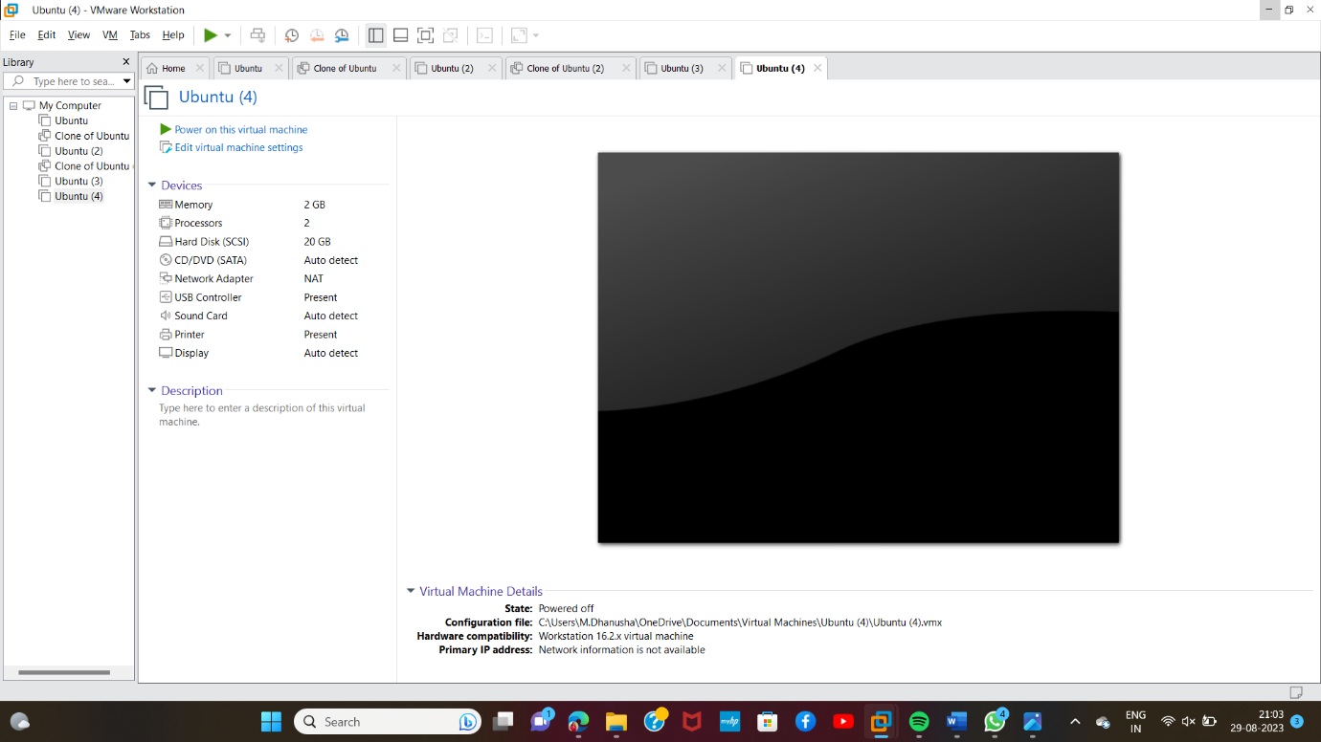

Result: succsefully implemented vm ware